Retail Marketing Campaign Analytics
A retail company wants to analyze customer buying behavior and marketing campaign performance using Snowflake sample data.
The company has three teams:
1. Marketing Analysts
2. Finance Team
3. ETL Developers
Each team should use a separate warehouse. The company also wants to improve query performance using:
1. Warehouse scaling
2. Query result cache
3. Cluster key on customer sales date
Use Snowflake sample data from:
SNOWFLAKE_SAMPLE_DATA.TPCDS_SF10TCL.STORE_SALES
SNOWFLAKE_SAMPLE_DATA.TPCDS_SF10TCL.CUSTOMER
SNOWFLAKE_SAMPLE_DATA.TPCDS_SF10TCL.DATE_DIM
SNOWFLAKE_SAMPLE_DATA.TPCDS_SF10TCL.ITEM
________________________________________
Questions
Part 1: Warehouse Setup
Create three warehouses:
1. MARKETING_WH for marketing analysts
2. FINANCE_WH for finance team
3. ETL_WH for ETL developers
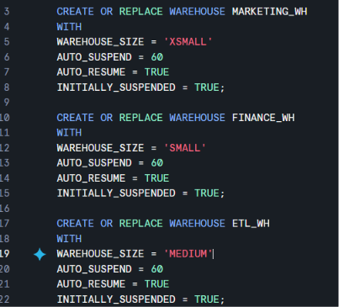
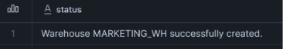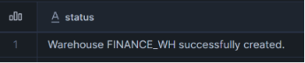
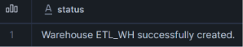
Part 2: Role Setup
Create three roles:
1. MARKETING_ANALYST
2. FINANCE_USER
3. ETL_DEVELOPER
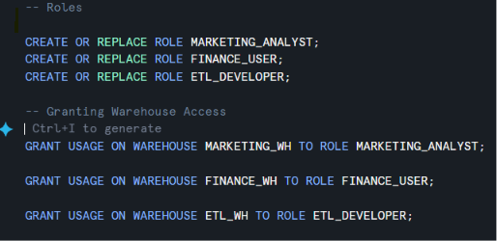
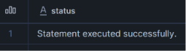
________________________________________
Part 3: User Setup
Create users:
1. MKT_USER1
2. FIN_USER1
3. ETL_USER1
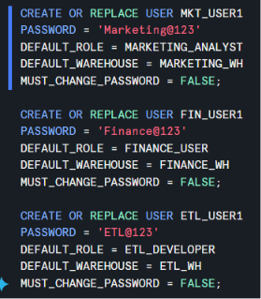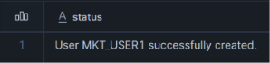
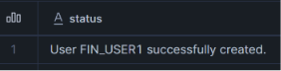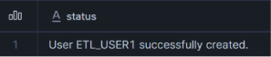
________________________________________
Part 4: Create Performance Demo Database
Create a database called:
RETAIL_MARKETING_DB
Create a table called:
CAMPAIGN_SALES
using Snowflake sample tables.
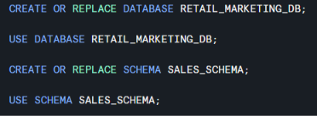
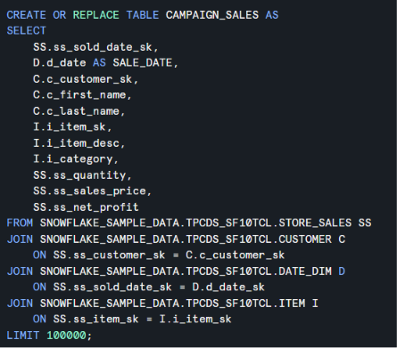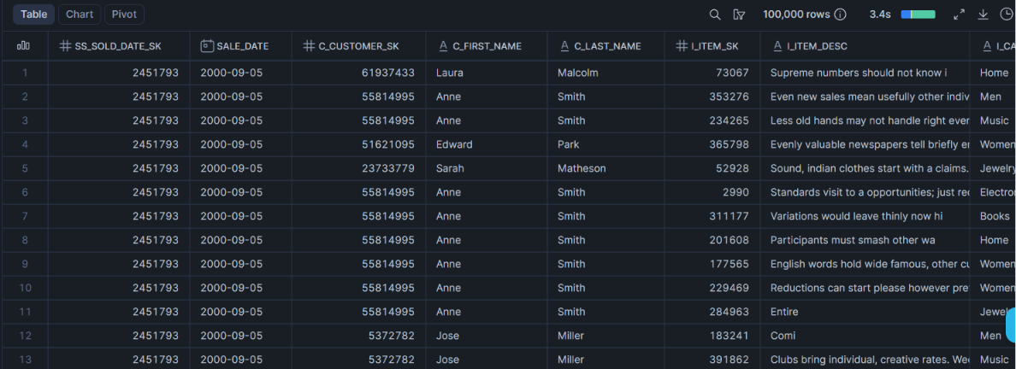
________________________________________
Part 5: Grant Permissions
Grant proper database, schema, and table permissions to each role.
Marketing and Finance can only read data.
ETL Developer can create and modify tables.
-- Database Access
GRANT USAGE ON DATABASE RETAIL_MARKETING_DB
TO ROLE MARKETING_ANALYST;
GRANT USAGE ON DATABASE RETAIL_MARKETING_DB
TO ROLE FINANCE_USER;
GRANT USAGE ON DATABASE RETAIL_MARKETING_DB
TO ROLE ETL_DEVELOPER;
-- Schema Access
GRANT USAGE ON SCHEMA RETAIL_MARKETING_DB.SALES_SCHEMA
TO ROLE MARKETING_ANALYST;
GRANT USAGE ON SCHEMA RETAIL_MARKETING_DB.SALES_SCHEMA
TO ROLE FINANCE_USER;
GRANT USAGE ON SCHEMA RETAIL_MARKETING_DB.SALES_SCHEMA
TO ROLE ETL_DEVELOPER;
-- Table Permissions
GRANT SELECT ON TABLE RETAIL_MARKETING_DB.SALES_SCHEMA.CAMPAIGN_SALES
TO ROLE MARKETING_ANALYST;
GRANT SELECT ON TABLE RETAIL_MARKETING_DB.SALES_SCHEMA.CAMPAIGN_SALES
TO ROLE FINANCE_USER;
-- ETL Full Access
GRANT ALL PRIVILEGES
ON ALL TABLES IN SCHEMA RETAIL_MARKETING_DB.SALES_SCHEMA
TO ROLE ETL_DEVELOPER;
GRANT CREATE TABLE
ON SCHEMA RETAIL_MARKETING_DB.SALES_SCHEMA
TO ROLE ETL_DEVELOPER;
________________________________________
Part 6: Performance Testing
Run a sales analysis query using XSMALL warehouse.
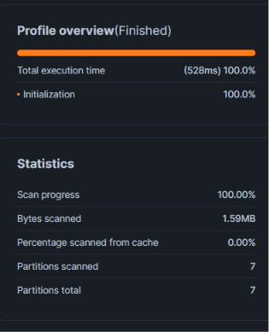
Then scale up the warehouse to SMALL.
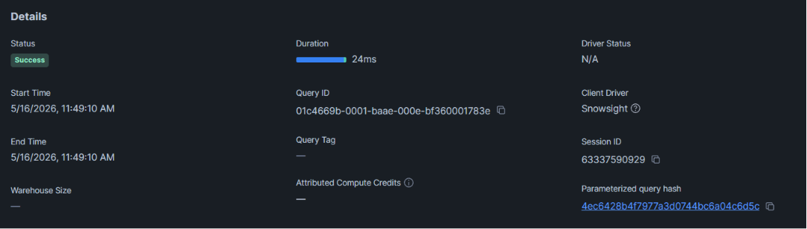
Compare performance.
Then scale it down again.
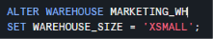
________________________________________
Part 7: Cache Testing
Run the same query twice.
Observe why the second query is faster.
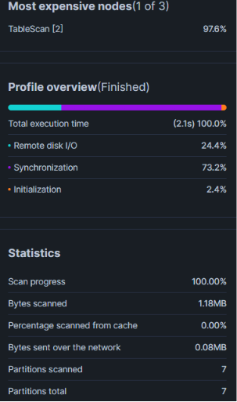
After
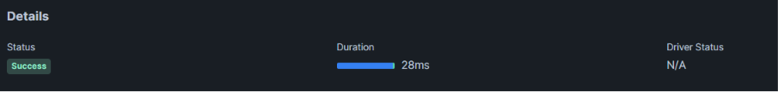
________________________________________
Part 8: Cluster Key Testing
Run a date-filter query before clustering.
Add cluster key on SALE_DATE.
Run the same query again.
Compare performance.
Before clustering:
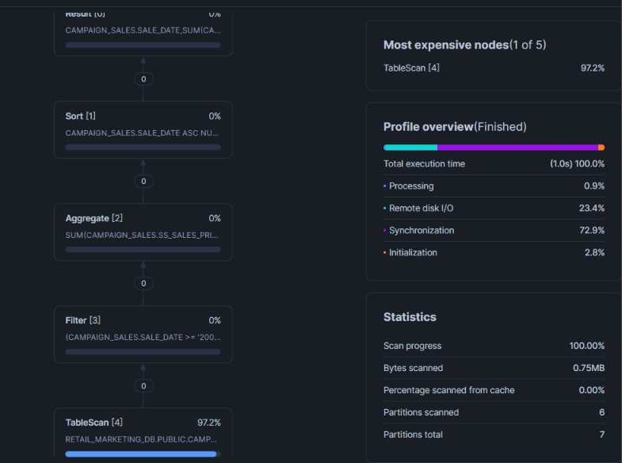
After clustering:
